Colin Hackett Scholarship

In November 2016, the North Region lost Colin Hackett, an inspirational mentor and official, after a two-year battle with colon cancer. Colin became an inspiration to many after his diagnosis, as he would officiate games days after undergoing chemotherapy treatment and continued to mentor younger officials. He also refereed for the World’s Longest Hockey Game while wearing his chemotherapy pack and undergoing treatment during the game. Off the ice, Colin gave a motivational speech to more than 2000 people at the Enbridge Ride to Conquer Cancer and then rode for 200 km with the group. During his courageous two-year battle with colon cancer, Colin continued to be a mentor to many officials and volunteered his time as Vice Chair.

Applications for this year’s Colin Hackett Memorial Scholarship are now open. Please go to https://officials.hockeyalberta.ca/officials-regions/north-region-edmonton-area/colin-hackett-award-application/ and click on the North Region Awards for all the requirements and rules for applying. This is open to all officials who are going to be attending post-Secondary education.

*** Applications will accepted until March 1, 2024***

Hockey Alberta Officials Committee Scholarship

Value

Annually – Maximum of three (3) awards of up to $1,500.

Scholarships are presented to applicants who meet the following criteria:

- A member in good standing with Hockey Alberta in the current season with a minimum of Level 2 certification.
- A resident of Alberta for at least 2 years.
- 18 years of age by December 15 of the season s/he is applying for scholarship.
- An active official, working games at any level.
- Attending a post-secondary institution in a recognized program on a full-time basis, including a recognized trade school program. Transcript of class enrolment is required.
- Go to https://officials.hockeyalberta.ca/awards/officials-committee-scholarship/officials-committee-scholarship-application/ to apply
- Other criteria will include, but is not limited to, the applicant’s on-ice ability and off-ice contribution to his/her Region.

Deadline

Application deadline is April 1 of each year.

Applicant could be applying for the year just being completed in order to qualify.

Kenneth R. Stiles Scholarship
The Kenneth R. Stiles Memorial Scholarship was established by the Seaman Hotchkiss Hockey Foundation (formerly Project 75) and Hockey Canada in recognition of Ken Stiles and his tremendous contribution to grassroots hockey in Canada.

Through the vision and leadership of the Seaman Hotchkiss Hockey Foundation, many Hockey Canada development programs have received their start. The Hockey Canada Officiating Program of Excellence is an excellent example of this support.
The Seaman Hotchkiss Hockey Foundation is committed to providing Canadian student athletes and officials with access to financial resources to support their pursuit of post-secondary education.

Scholarships are allocated (one major award of $5,000 and three minor awards of $1,000 each) for both Male and Female officials. Male recipients must have been part of the Hockey Canada OPEO in the past and female officials must be at minimum Level 3 certification.

The deadline for applications is April 15, 2022. Full criteria are included in the application form package

Edmonton Invitational TOC Scholarship

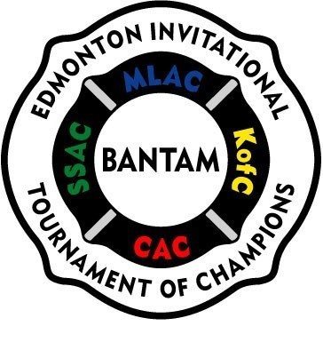

The Edmonton Invitational Bantam Tournament of Champions is providing the North Region Officials with a $1000 scholarship to be awarded to an official who officiated at the Bantam level this season. Officiating in the annual Edmonton Invitational Bantam Tournament (EBIT) of Champions would be a plus. The funds will be held in escrow until the official provides the EBIT Scholarship Committee with an official receipt showing proof of registration or tuition payment to a post-secondary education institution. Should the official not provide such and reach the age of 23 years old, the scholarship will be returned to the EBIT Scholarship Fund.

The criteria for the award is:

- Academic accolades (current marks as of March 1). A letter from current registered school will provide information.
- Athletic accolades, if any.
- Applicant to write an essay (minimum 200 words) outlining why s/he deserves the scholarship and what being an official has done for him or her.
- Letters of Reference.

Please apply to the EBIT Scholarship Committee at https://officials.hockeyalberta.ca/officials-regions/north-region-edmonton-area/north-region-awards/ no later than March 1 of the current season. Nominees may be interviewed.

Only the successful candidate will be notified, and the name will be posted on the EBIT and Hockey Alberta Officials website. No individual can win more than one scholarship.

